AI 5200 Project 1 Report
David Everett

Part 1 Final Models
The original baseline used 30 residual blocks, stream width 128, hidden width 256, tanh, pre-LayerNorm, Xavier initialization, and a two-layer classifier. It trained with plain SGD at learning rate 0.05 and batch size 256, without momentum, a scheduler, regularization, or augmentation. The baseline trained for 10 epochs on MNIST, 30 on CIFAR, and 10 on ImageNet.
Architecture | MNIST | CIFAR-10 | ImageNet32
Model | Flat residual MLP | Residual patch MLP | Residual patch MLP
Residual blocks | 10 | 6 mixing blocks | 12 mixing blocks
Stream width | 392 | 128 per patch | 128 per patch
Hidden width | 1,024 | Token 64; channel 256 | Token 64; channel 256
Image grouping | 784 pixel values | 64 patches of 4x4 RGB pixels | 64 patches of 4x4 RGB pixels
Activation | Two-piece Maxout | GELU | GELU
Normalization | BatchNorm | LayerNorm | LayerNorm
Classifier | Linear to 10 classes | Patch mean; 128 to 256 to 10 with GELU | Patch mean; linear 128 to 1,000

Every linear weight matrix starts with Xavier normal initialization and zero bias. In the patch models, normalization occurs before each residual branch and before averaging the patches. As a note, the MNIST settings still contain an activation value of GELU, but Maxout replaces the branch activations and the classifier is linear, so GELU is not used in that model's forward pass. Similarly, the nested patch settings determine the actual CIFAR and ImageNet depths; the unused flat-model settings do not describe those models.

Training recipe | MNIST | CIFAR-10 | ImageNet32
Optimizer | AdamW | SGD; momentum 0.9 | SGD; momentum 0.9
Initial learning rate | 0.001 | 0.05 | 0.05
Epochs | 40 | 90 | 20
Batch size | 256 | 256 | 256
Schedule | Cosine toward 0.00001 | Cosine toward 0.00001 | Cosine toward 0.00001
Weight decay | 0.01 | 0 | 0
Branch dropout | 0.1 | 0.1 | 0
Augmentation | Rotation up to 7 degrees; shifts up to 2 pixels; black padding | Horizontal flip probability 0.5; shifts up to 2 pixels with reflection; RGB jitter 0.05 | Horizontal flip probability 0.5; noise standard deviation 0.02; RGB jitter 0.05

CIFAR's MLP classifier has no dropout. Neither RGB model uses rotation in its final recipe, and ImageNet does not use translation. The momentum entry in the MNIST dictionary is inactive because that task uses AdamW.
Task | Baseline accuracy | Best recorded accuracy | Gain in points | Recorded training time
MNIST | 95.95% | 99.27% | 3.32 | Baseline 1.1 min; best 2.5 min in LOG, local GPU
CIFAR-10 | 48.62% | 78.11% | 29.49 | Baseline 4.8 min local; best 4.1 min on HPC
ImageNet32 | 6.77% | 25.42% | 18.65 | Baseline 37.2 min local; best 37.0 min on HPC

Part 2 What Mattered Most

Processing Images as Patches
The patch configuration produced my largest improvement. For example, CIFAR Change 15 improved the best accepted flat-model accuracy from 63.12% to 71.71%, a gain of 8.59 percentage points; the previous trial scored 62.40%, making that change a direct increase of 9.31 points. ImageNet Change 1, enabling the patch architecture, improved its original 6.77% baseline to 13.54%.
A 4x4 RGB patch contains 48 values, and the shared projection converts each patch into 128 learned features. Token mixing combines information between patch positions, and channel mixing combines features within a patch. This provided the models a useful way to process local groups, but a flat model still retains positions through its input indices, so flattening did not erase all spatial information.

Making the earlier flat model wider and shallower
Before using patches, CIFAR Change 2 increased width from 128 to 512 and hidden width from 256 to 1,024, reduced depth from 30 to 8, introduced SwiGLU branches, and used a linear classifier. Accuracy improved from 48.62% to 55.10%. This was a 6.48-point gain, but several settings changed together to say that SwiGLU caused it by itself.
Change 3 then replaced SwiGLU with two-piece Maxout and improved 55.10% to 57.68%. Both models reached nearly zero training loss while their test accuracy remained much lower, meaning they could fit the training images but still needed a better way to generalize. So, I experimented more with augmentation and eventually patch processing.

Replacing Tanh with GELU
ImageNet Change 3 improved accuracy from 17.29% to 21.42%, a gain of 4.13 points, while final training loss decreased from 4.1471 to 3.7395. I chose GELU because tanh saturates to 1 for large inputs, whereas GELU does not cap large positive outputs. The result supported keeping GELU. However, I did not measure saturation in the earlier tanh trial, so its lower performance alone does not prove that saturation caused the problem.

Adding Momentum
ImageNet Change 2 increased SGD momentum from zero to 0.9 and improved 13.54% to 17.29%. Its training loss similarly decreased from 4.5708 to 4.1471. Momentum combines recent gradient directions with the current gradient, which helped the model make more progress within the same number of epochs.
CIFAR Change 7 also improved accuracy, from 59.35% to 63.12%. Its augmented training loss increased from 0.4660 to 0.5293, so momentum did not simply lower every loss value. This reinforces the concept that test data performance matters more than selecting the smallest training loss.

Choosing Useful Augmentation and Regularization
CIFAR Change 17 added dropout and improved accuracy from 71.71% to 72.76%. Change 18 removed rotation and noise together, improving accuracy to 75.45%. These changes suggest that regularization helped, but some image transformations were making the small images harder to learn from without adding useful variation. Removing the two transformations at once obscures which one contributed more to the decreased accuracy.
MNIST benefited from shifts because Change 25 improved accuracy from 98.82% to 99.01%, finally crossing the 99% threshold. Later rotation helped reach its best of 99.27%. The final RGB jitter trials added smaller gains, from 77.82% to 78.11% on CIFAR and 24.80% to 25.05% on ImageNet. My RGB jitter slightly changes an image’s red, green, and blue channel intensities during training to help the model recognize objects despite small differences in color and lighting.
Other changes helped finish the recipes. ImageNet Change 8 increased patch depth from 6 to 12 and improved accuracy from 21.99% to 23.26%. The first Change 9 doubled epochs from 10 to 20 and reached 24.80% accuracy. Its final cosine trial reached 25.42%. For CIFAR, Change 21 added an MLP classifier and improved 76.01% to 77.63%; increasing from 80 to 90 epochs in Change 22 reached 77.82% before RGB jitter.

Complete CIFAR-10 Recipe Comparisons
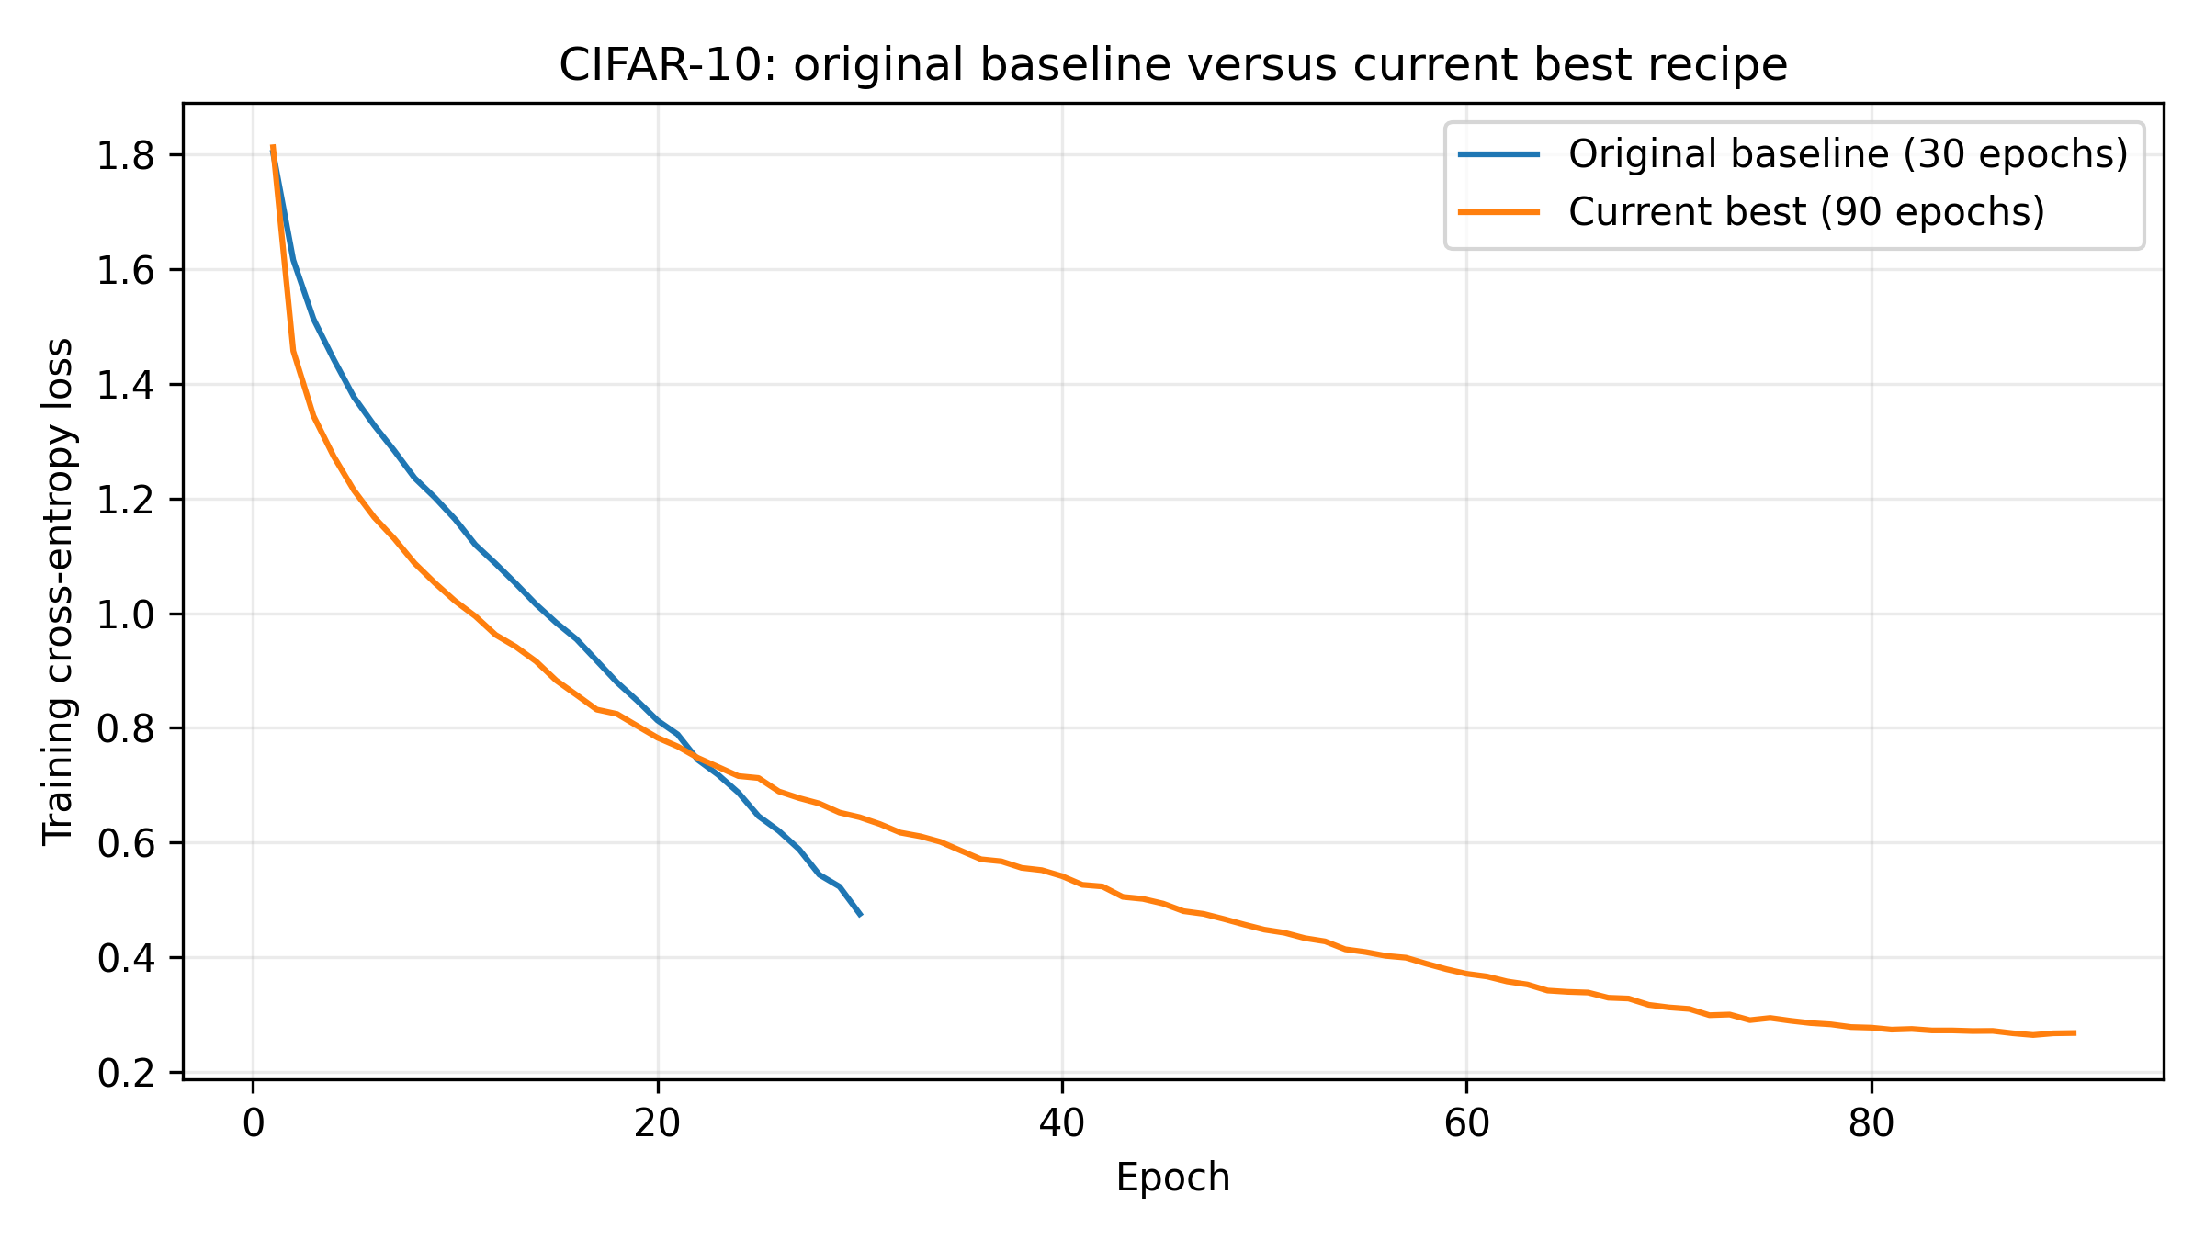
Figure 1. CIFAR-10 baseline model versus best model training loss
Both curves began near 1.8 loss. At epoch 10, the best recipe had lower loss, 1.0211 versus 1.1638. At epoch 30, the baseline was lower, 0.4750 versus 0.6438. The best recipe then continued to 0.2672 at epoch 90. Because this compares complete model differences along with the training conditions given augmentation and dropout, the lower baseline loss at epoch 30 does not establish better generalization for the baseline.

Part 3 Training Dynamics and Ablation on ImageNet32 Model

How I Measured the Model
I used analysis.ipynb to train my final ImageNet architecture from scratch and measure what happened inside it. The notebook uses the same model settings as the harness, but holds out five training images per class for validation. This left 1,276,167 training images and 5,000 validation images. I reused the same clean batch of 128 other training images at initialization and after epochs 2, 10, and 20. All measurements used eval mode so changes came from training rather than different images or dropout.
For gradients and updates, the notebook copied the model and optimizer together. It calculated the fixed-batch loss with gradients enabled, took one real optimizer step on the copy, and discarded it. This preserved momentum without changing the model being trained. Measurements happened before the scheduler advanced, using the learning rate from the completed epoch. The notebook and saved CSV files make these measurements repeatable without adding analysis work to the graded training function.

Learning Curves
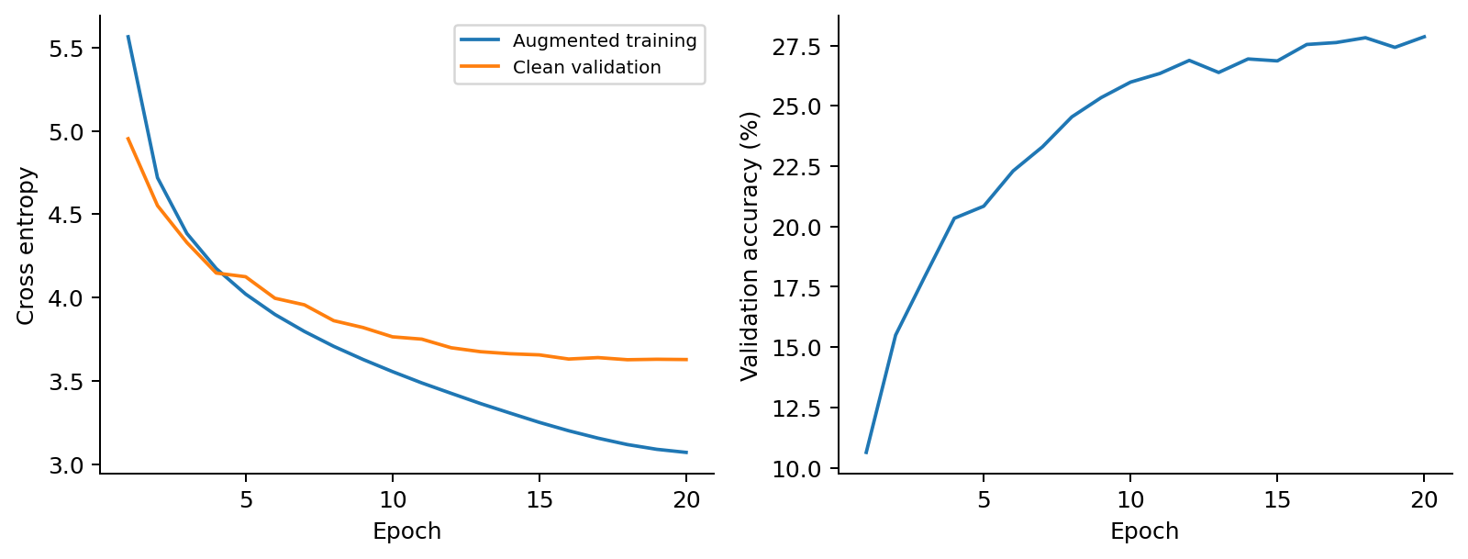
Figure 2. ImageNet analysis training loss, clean validation loss, and validation accuracy
On ImageNet, training loss decreased from 5.5648 at epoch 1 to 3.07 at epoch 20. Validation accuracy increased from 10.64% to 27.86%, while validation loss decreased from 4.9527 to 3.6273, and training took 35.69 minutes on the remote HPC cluster with one GPU. The 27.86% validation result uses this held-out training split, so it’s separate from the 25.42% harness score.
Through the epochs, the model kept learning, but the later gains were smaller; validation accuracy was already 25.98% at epoch 10. Validation loss was lowest at epoch 18, at 3.6262, and was almost unchanged at the end. This suggests diminishing returns near the end rather than a sudden failure to generalize. Training loss uses augmented images and is averaged during updates, while validation is measured afterward on clean images, thus their difference includes more than overfitting alone.

Activation Variance
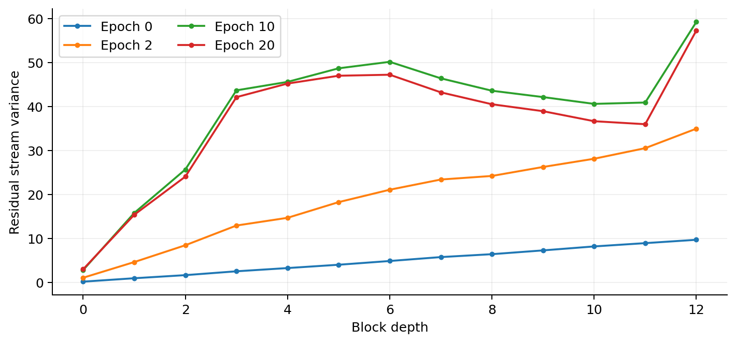
Figure 3. Residual stream variance after projection and each block at four checkpoints
Variance measures how widely values spread around their mean. I measured it across the examples, patches, and features after the patch projection and every complete block. Figure 3 shows that the residual stream grew with depth. At initialization, variance increased from 0.1616 after projection to 9.6826 after block 12. At epoch 20, it increased from 2.9792 to 57.2737, about 19.2 times the projection variance.
The final profile was not a steady increase. Variance reached 47.2295 after block 6, decreased to 35.9753 after block 11, and then increased in block 12. Residual corrections can strengthen or cancel parts of the existing signal. LayerNorm normalizes branch inputs, but it does not reset the accumulated stream to variance one. The signal grew, but the measured profiles and continued learning do not support calling this an uncontrolled numerical explosion.

Branch to Stream Ratio
$$Branch ratio = \frac{RMS(branch correction)}{RMS(branch input)}$$
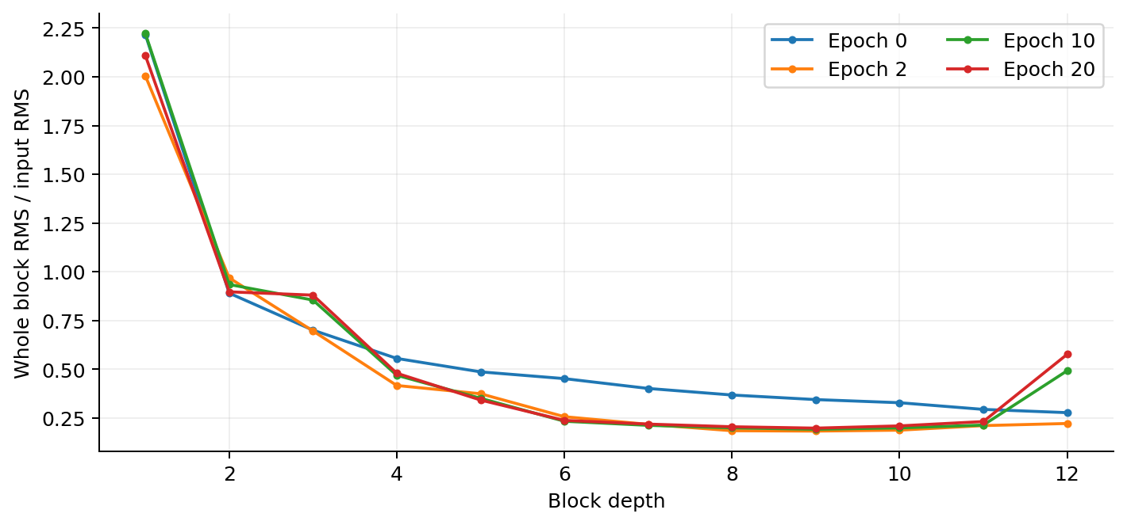
Figure 4. Whole-block correction RMS divided by the RMS of its input stream
RMS measures a signal's typical magnitude. The branch-to-stream ratio divides the correction's RMS by its input's RMS. I recorded token and channel branches separately, plus the complete block correction. The channel branch receives the stream after token mixing has already been added.
Figure 4 shows large early corrections and smaller corrections through much of the later network. At epoch 20, the whole-block ratio was 2.109 in block 1, 0.898 in block 2, and 0.199 in block 9. It rose again to 0.577 in block 12. The final token ratios in blocks 8–11 were about 0.106–0.133. These branches changed the stream relatively little, but their corrections were not zero. A falling ratio can also reflect a growing input stream, so I used ablation to check whether small corrections were actually unimportant.

RMS Gradients
$$RMS(g) = \sqrt{mean(g^{2})}$$
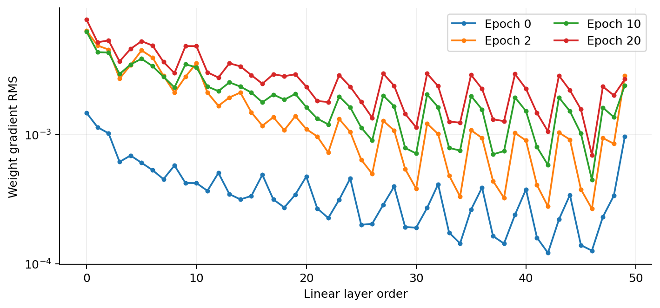
Figure 5. Weight gradient RMS for all 50 linear matrices at four checkpoints
I measured gradient RMS for all 50 linear weight matrices. Figure 5 uses linear-layer order: the projection comes first, followed by four matrices per mixing block and the classifier. Its horizontal axis is therefore not the block number.
All matrices had finite, nonzero gradients at all four checkpoints. At epoch 20, the largest gradient RMS was 0.007776 in the patch projection. The smallest was 0.000699 in the final token branch's output projection. Earlier layers generally had larger gradients, with repeated peaks between different matrix types. The measured gradients do not support an obvious vanishing or exploding gradient problem. Howver, this does not mean every layer's scale was ideal, and four checkpoints cannot describe every training step.

Update to Weight Ratio
$$Update ratio = \frac{RMS(weights after step - weights before step)}{RMS(weights before step)}$$
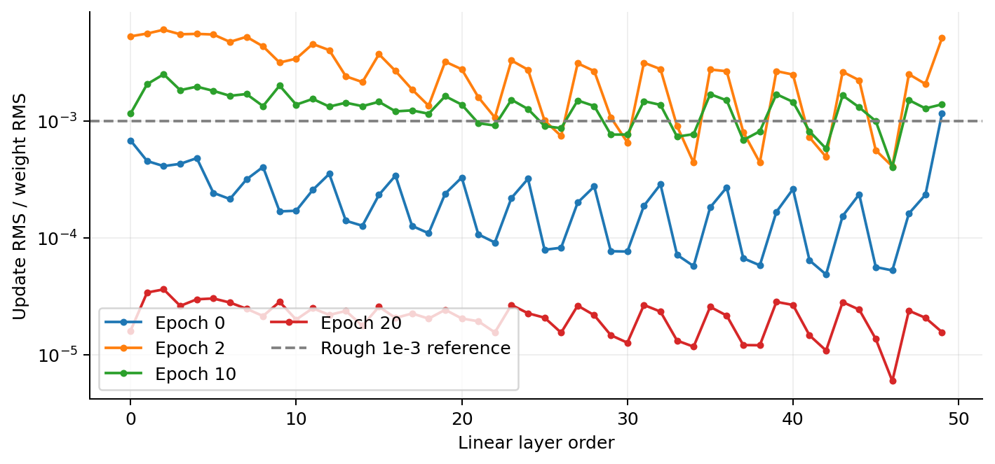
Figure 6. Actual diagnostic optimizer update RMS relative to weight RMS
This ratio divides the RMS weight change from one diagnostic optimizer step by the RMS weights before that step. A ratio of 0.001 means the update's RMS is one thousandth of the weights' RMS. Taking an actual copied optimizer step matters because momentum carries information from previous updates. Initialization has no accumulated momentum yet.
In Figure 6, update ratios ranged from about 0.000408 to 0.006022 at epoch 2. By epoch 20, they ranged from about 0.000006 to 0.000036. The small final ratios agree with the cosine schedule: the probe learning rate fell from 0.05 to 0.0003177, about 157 times smaller. Gradients had not disappeared. I would therefore not diagnose a bad learning rate just because the final ratios were below the approximate 0.001 reference. The final probe occurs before the scheduler's last step to 0.00001.

Saturation
My final ImageNet model uses GELU, so the requested tanh and ReLU saturation statistics do not apply.

Which Branches Mattered
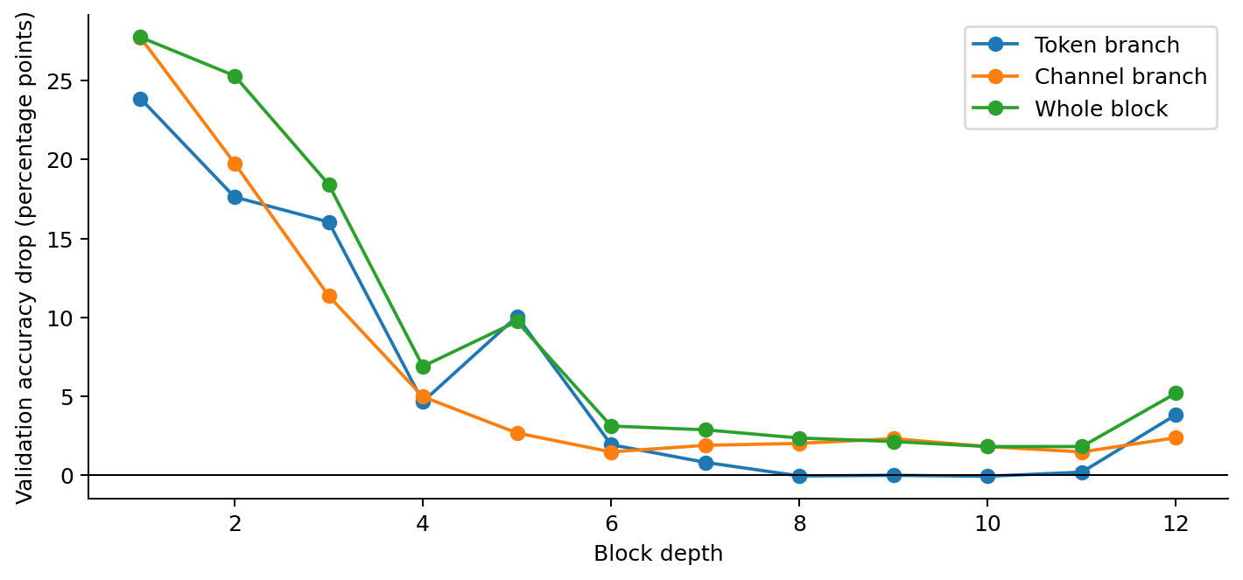
Figure 7. Validation accuracy drop after individual branch and whole-block removals
Each patch block has a token and channel correction, giving 24 individual branch tests. Returning a zero correction preserved its skip connection. I also bypassed each complete block by returning its input, giving the twelve whole-block points in Figure 7. Every removal was restored before the next test. Accuracy drop is the full model's 27.86% validation accuracy minus the ablated accuracy, expressed in percentage points.
The network relied heavily on its early blocks; for example, removing complete blocks 1, 2, and 3 reduced accuracy by 27.74, 25.30, and 18.42 percentage points. Bypassing block 1 left only 0.12% accuracy, close to the 0.1% accuracy of random guessing across 1,000 classes. In contrast, token branches 8 and 10 could be removed with tiny measured improvements of 0.04 and 0.06 points. These represent only two and three additional correct predictions out of 5,000, so they didn’t provide a reliable improvement. Token branch 9 had zero net accuracy change, but lost 64 correct predictions and gained 64 others, so it still affected individual predictions. However, the deeper network was not entirely unnecessary. Removing whole blocks 10 or 11 still cost 1.82 points each, and removing block 12 cost 5.20 points, plus channel branches also retained useful contributions.
The ratios broadly agreed with ablation: larger whole-block corrections tended to produce larger accuracy drops, with a Pearson correlation of about 0.885 across these twelve blocks. Still the ratios and ablation didn’t match perfectly: block 5 had a smaller ratio than block 4, but its removal caused a larger drop. My conclusion is that the model used its depth unevenly. Individual ablations suggest where redundancy may exist, but they do not show that several branches can be removed together or that a shallower model would train equally well from scratch.

Part 4 What Didn’t Work
More depth did not always help. CIFAR's two Change 16 entries tested 12 and then 10 patch blocks. Twelve blocks reduced training loss from 0.3877 to 0.2529 but reduced accuracy from 71.71% to 70.06%. Ten blocks reached 70.88%, still below six. This is consistent with poorer generalization under that recipe. I returned to six blocks rather than assuming a larger model must perform better.
CIFAR Change 9 replaced LayerNorm with BatchNorm. Training loss decreased from 0.5293 to 0.2308, but accuracy decreased from 63.12% to 62.22%. BatchNorm worked in the later MNIST Maxout recipe, so this trial did not show that either normalization method was always superior. It showed that the choice interacted with the task and model.
The MLP classifier also behaved differently across tasks. It helped CIFAR, but ImageNet's second Change 9 reduced accuracy from 24.80% to 23.92% and increased loss from 3.2406 to 3.2771. I restored ImageNet's linear classifier. The extra layer added capacity but did not improve this training recipe. The experiment does not establish whether the cause was optimization, generalization, or a need for different settings.
AdamW did not beat the tested momentum-SGD parents on CIFAR or ImageNet. CIFAR Change 8 reached 62.47% compared with 63.12%, and ImageNet Change 7 reached 20.84% compared with 21.99%. Both used AdamW at learning rate 0.001. These replacements were worse under the settings tested; that does not make AdamW generally unsuitable. It remained useful in the MNIST recipe.
Extra augmentation sometimes hurt. MNIST noise reduced its recorded best from 99.27% to 99.14%, while ImageNet translation changed 21.71% to 21.58%. Removing CIFAR rotation and noise improved its patch model. My explanation is that some transformations may obscure details in already small images or need more training to become useful. The accuracy results alone do not prove that explanation. Gaussian noise changes individual pixels; it is not the same operation as blurring an image.
MNIST label smoothing changed 98.46% to 98.42%. Its loss of 0.2830 used smoothed target probabilities, so it should not be compared directly with ordinary cross-entropy. Reducing batch size to 64 reached 98.25% and increased training time to 4.9 minutes. These trials showed why a plausible idea still needed to be tested rather than kept because of its explanation alone.

Part 5 Across the three tasks
MNIST has ten grayscale categories with fairly consistent digit structure. A flat MLP could use its 784 pixel inputs effectively. Small positional changes helped it recognize handwriting in different places and at slightly different angles. Its Maxout, BatchNorm, and linear-classifier combination worked well together. The historical result was already close to perfect accuracy, leaving limited room for further gains.
CIFAR also has ten categories, but color objects, backgrounds, and positions vary more. The flat models could fit the training images closely while remaining much less accurate on unseen examples. Patch processing provided a more useful organization of image information. The final recipe uses six mixing blocks, dropout, shifts, horizontal flips, RGB jitter, an MLP classifier, and more training. Increasing patch depth hurt under the tested recipe, while improving the classifier helped.
ImageNet32 has 1,000 classes and many more training images. It must separate more varied and fine-grained categories from only 32x32 pixels. Twelve mixing blocks improved its result, but the extra classifier layer did not. I kept a linear classifier, no dropout, and mild flipping, color, and noise augmentation. Twenty ImageNet epochs also involve far more training examples than twenty CIFAR epochs, so epoch counts alone do not compare computation fairly.
These results show that more parameters were not enough by themselves. Shared patch processing and the training recipe mattered, and depth had to be justified by its contribution. The ImageNet ablation supports that conclusion: early blocks were essential, some later token branches were less useful individually, and the final block still mattered. The experiment does not establish a universal accuracy limit for MLPs, but it shows that their way of processing image structure is a major constraint.
Most development results used one seed, and harness scores influenced which changes I kept. I therefore treat small gains as observations from model selection rather than untouched estimates of generalization. The separate ImageNet validation analysis provides a consistent comparison within one newly trained model, while the harness records remain the reported task scores.

Part 6 Explanations beyond the basics

Patch mixing
The patch model follows the basic MLP-Mixer idea [1]. One shared linear projection embeds each patch. A token MLP mixes patch positions for each learned feature, while a channel MLP mixes features within each patch. Each branch adds a correction through a residual connection. After the last block, normalized patch features are averaged into one vector for classification. The channels inside these blocks are learned features, not just the original red, green, and blue channels. I used this structure because it improved image recognition while keeping the network within the allowed MLP building blocks.

Maxout and gated activations
Two-piece Maxout learns two candidate values for each hidden feature and keeps the larger [2]. Its preceding linear layer therefore produces twice the resulting hidden width. This lets the model learn which candidate is more useful for each input. I kept Maxout in MNIST based on its measured performance with BatchNorm.
GELU smoothly weights an input according to its value [3]. It reduces much of the negative range while allowing large positive values to continue increasing. Its ImageNet trial improved both loss and accuracy. SwiGLU instead splits a wider linear output into a gate and a value, applies SiLU to the gate, and multiplies them [4]. I tested it in the earlier flat CIFAR model, but did not retain it in the final models. Its published Transformer results motivated an experiment rather than guaranteeing an image-classification gain.

Regularization and optimization
Dropout temporarily sets a random fraction of hidden activations to zero during training, then is disabled during evaluation [5]. This discourages dependence on a few features. I use probability 0.1 in the MNIST and CIFAR residual branches. AdamW adapts update sizes using recent gradient statistics and applies weight decay separately from those adaptive calculations [6]. It is used for MNIST; CIFAR and ImageNet use momentum SGD. Momentum combines the current gradient with a running contribution from previous gradients.
Cosine scheduling gradually reduces the learning rate toward a chosen minimum [7]. All three final recipes use a minimum of 0.00001. Early updates can make larger changes, while later updates refine the weights more gently. This also explains why small final update-to-weight ratios are not automatically evidence that gradients have vanished. Xavier initialization gives linear matrices a starting scale based on their input and output sizes, and the pre-normalized residual path helps keep branch inputs controlled. Neither makes every residual-stream variance constant.

Image transformations
Augmentation changes the supplied images as they enter a training batch. It does not introduce external images or permanently enlarge the dataset. Shifts move an image by up to two pixels; rotations select a small angle; horizontal flipping mirrors left and right. Reflection padding uses nearby reflected image content at exposed borders, while MNIST uses black padding.
RGB jitter selects one multiplier between 0.95 and 1.05 for each image's red, green, and blue channel. A multiplier is shared across all pixels in that channel, changing color balance consistently. The code converts prepared images back to the 0-1 range before multiplying, then returns to -1 to 1. Gaussian noise instead changes individual pixels independently. ImageNet's noise standard deviation is 0.02 in the prepared -1 to 1 space, followed by clipping. I kept different transformations for each task because the experiments showed that useful variation depended on the images.

